Howard University
College of Engineering and Architecture
Department of Electrical Engineering & Computer Science

Large Scale Programming
Fall 2024

Midterm Exam – Part I
October 17, 2024

Part I: 50 pts. (essay questions)

Instructions:
- Submit completed exam to your github repository under package org.howard.edu.lsp.midterm

Verify that the commit(s) completed successfully

- OPEN BOOK, OPEN NOTES. THERE IS NO COLLABORATION ON THIS EXAM
- Site any and ALL references for anything obtained off the internet.

Question 1. (10 pts.)

You are reviewing the following class in a Fitness Tracking System. The class is intended to manage various aspects of a user’s fitness activities.

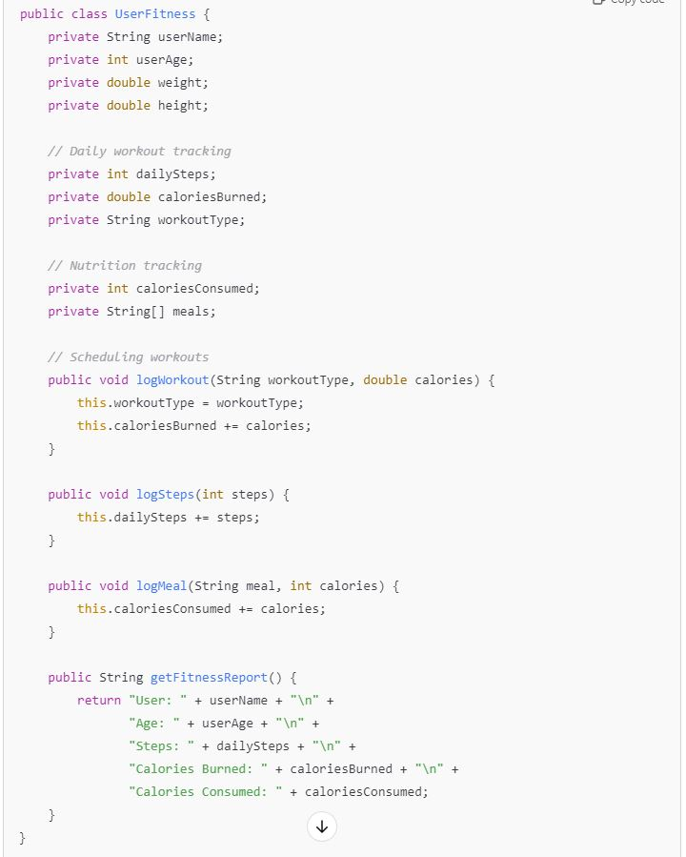

Tasks:
- Analyze the UserFitness class. Explain why this class has low cohesion. (5 pts.)
The UserFitness class isn't very cohesive because it's trying to juggle too many different tasks. It handles user details like their name and age, keeps track of workouts and steps, and also monitors nutrition by logging meals and calories consumed. When a class takes on multiple unrelated responsibilities like this, it becomes a bit of a mess to maintain and understand. It would be much cleaner to separate these concerns into individual classes focused on specific functionalities—like one for user info, one for workout tracking, and another for nutrition. This way, each class has a clear purpose, making the code easier to work with and stick to good object-oriented design principles.

- Describe, in general, how you would split the UserFitness class into more cohesive classes. Your answer should not be a complete design. (5 pts.)

we should consider splitting it into separate classes that each handle a specific aspect of user fitness. For example:
- UserProfile: This class would manage user details like name, age, weight, and height.
- WorkoutTracker: This one would keep track of workout data such as steps taken and calories burned.
- NutritionTracker: This class would handle nutrition information, logging meals and calories consumed.
This way, each class would have a clear and singular purpose. This makes the code easier to understand and maintain because changes in one won't impact other areas. It's just way more organized and it is also a good coding practices

Question 2. (5 pts.)
Given the following, answer the below questions.
A university manages its students using a program that has a class Student with subclasses FirstYear, SecondYear, and ThirdYear for year-specific state and behaviors. The program has a List that contains all Students.

Should Student be a class, an abstract class or an interface? Explain your answer

- At the end of each year, the third-year students graduate and must be removed. This is done by passing the list to the following method:

void removeThirdYears(List<Students> students) {
for (Student student : students) {
try {
ThirdYear = (ThirdYear) student;
students.remove(thirdyear);
}
}
}

Why is the above method flawed? Hint: Another Arthur Riel heuristic (5 pts.)

Should Student be a class, an abstract class or an interface?
Student should be an abstract class. This allows us to define common attributes and methods shared by all students, like name and ID, while preventing the creation of generic Student instances that don't belong to a specific year. FirstYear, SecondYear, and ThirdYear can inherit from Student and implement their own specific behaviors. An interface isn't suitable because it can't hold shared code or state, and a regular class isn't ideal if we don't want to instantiate generic Student objects.

Why is the above method flawed?

It is flawed because it modifies the students list while iterating over it using a for-each loop, which can cause a ConcurrentModificationException or lead to unpredictable behavior. Additionally, it uses exceptions for control flow by casting each Student to ThirdYear and catching a ClassCastException if the cast fails. According to Arthur Riel's heuristic, you should avoid modifying a collection while iterating over it and should not use exceptions for regular control flow.

To safely remove elements from a list while iterating, you should use an Iterator:

void removeThirdYears(List<Student> students) {
Iterator<Student> iterator = students.iterator();
while (iterator.hasNext()) {
Student student = iterator.next();
if (student instanceof ThirdYear) {
iterator.remove();
}
}
}

Question 3. (5 pts.)
Given the following, answer the below questions.

public class BankAccount {
public String accountHolderName;
public String accountNumber;
public double balance;
public double interestRate;

public BankAccount(
String accountHolderName,
String accountNumber,
double initialDeposit,
double interestRate) {
this.accountHolderName = accountHolderName;
this.accountNumber = accountNumber;
this.balance = initialDeposit;
this.interestRate = interestRate;
}

// Exposed implementation for adding interest
public void addInterest() {
double interest = balance * (interestRate / 100);
balance += interest;
}

// Exposed implementation for deposits
public void deposit(double amount) {
balance += amount;
}

// Exposed implementation for withdrawals
public void withdraw(double amount) {
balance -= amount;
}
}

- Is BankAccount well-encapsulated? Why or why not? If so, describe what changes you would make to the class. Otherwise, state nothing. (5 pts.)
No, BankAccount class isn't well-encapsulated. All the fields—like accountHolderName, accountNumber, balance, and interestRate—are declared as public. This means anyone can access and modify them directly from outside the class, which isn't a good idea.
To improve this, you should make these fields private. This way, you control how they're accessed and modified. You can then provide getter and setter methods for any fields that need to be accessed from outside the class. For example, methods like getBalance() or setInterestRate(double rate).

Also, it's a good idea to add some validation in your methods. For instance, in the withdraw method, you might want to check if the amount is greater than the balance to prevent overdrawing the account.

By encapsulating the fields and adding proper validation, you make the class more secure and maintainable.

Question 4. (10 pts.)
Given the following, answer the below questions.

Given:
A car manufacturer uses Java software to track current vehicles being built. The UML diagram below shows an excerpt of the current software structure. You should assume the presence of other appropriate fields and methods

Car
getTrimLevel()
Engine
accelerate()
getFuelLevel()
Base
Sports
Luxury
Electric
Petrol

Each car can be built to one of three trim levels: Base, Luxury or Sport. They can also be configured with an electric or petrol engine. At various points in the manufacturing process the customer can choose to change the trim level.

Task:
- Explain in detail why the current structure does not support this. (5 pts.)

The current structure uses inheritance for the trim levels (Base, Sports, Luxury), which tightly couples the car's type to its class. This makes it impossible to change a car's trim level once it has been created. For example, a Base car cannot change to a Sports car without creating a new object. This rigidity comes from using inheritance, where a class is bound to its subclass behavior.

- Describe how to refactor the structure to allow trim-level change for a car to dynamically change. Hint: How would you modify Car to use composition to solve the problem? (5 pts.)

You can apply composition. Instead of having trim levels as subclasses, you can introduce a TrimLevel class or interface that Car can hold as a field. This way, the Car class does not need to know the specific type of trim; it can interact with the TrimLevel object and switch it out dynamically as needed.

You could refactor this way:
- Create a TrimLevel interface or abstract class with implementations like Base, Sports, and Luxury.
- In the Car class, add a private TrimLevel field and methods like setTrimLevel() to allow changing the trim level dynamically.
- This allows the car’s trim to be changed at any point during the manufacturing process by updating the trimLevel field without altering the car's class itself.

Question 5. (5 pts.)
Suppose you are about to code a particular class and find that you have written another class with nearly the functionality that you now are developing. This means that the two classes in large parts contain the same code, but in smaller parts have different code. Explain in detail why this may be a problem and how to solve it. Give your answer in terms of Arthur Riel’s design heuristics.

Having two classes that are mostly the same but differ in small ways is a problem because it leads to code duplication. This makes maintenance harder since any changes or fixes need to be made in multiple places, increasing the risk of errors. According to Arthur Riel's design heuristics, we should avoid duplicate code to keep our codebase clean and manageable.
To solve this issue, you can refactor the shared code into a common superclass that both classes inherit from. Alternatively, you could extract the common functionality into a separate class and have both original classes use it through composition. This way, you eliminate duplication and adhere to good object-oriented design principles.

Question 6. (5 pts.)
Suppose we need to store instances of the classes Car and BankAccount in a database. To obtain low coupling it may seem as if the functionality to save an instance should be in precisely those classes, since they have the information that shall be saved. Why is it unwise to place the database calls there?

Placing database calls directly inside the Car and BankAccount classes is problematic because:
- Breaks the Single Responsibility Principle: These classes should focus on their core logic (like managing car or account details), not handling database tasks. Mixing in database logic makes them responsible for two things.
- Limits Flexibility: If the database changes, you'll have to modify the entire class. Keeping database access separate makes it easier to switch databases or make changes.
- Reduces Reusability: These classes become tightly tied to the database, making it harder to use them in other contexts where you might not need database access.
It's better to keep the database logic in a separate layer, which keeps things cleaner and more adaptable.

Question 7. (5 pts.)
Given a set of requirements, what conditions must be met to make it appropriate to create a new class hierarchy using inheritance? Neither superclass nor subclass exist before, the question is about designing a new class hierarchy.

You should create a new class hierarchy using inheritance when:
- There's a clear "is-a" relationship between the classes (e.g., a Dog is an Animal).
- The classes share common attributes and behaviors that can be placed in a superclass.
- Subclasses have unique features or behaviors that need to be implemented separately.
- Using inheritance will help you organize your code better and promote code reuse.
If these conditions are met, then setting up a class hierarchy with inheritance makes sense for your design.

Question 8. (2.5 pts.)
Describe the difference between inheritance and composition why would you choose one over the other.

Inheritance is when a class inherits properties and methods from another class, representing an "is-a" relationship. For example, a Car class might inherit from a Vehicle class.
Composition is when a class contains instances of other classes as members, representing a "has-a" relationship. For example, a Car class might have an Engine object.
You'd choose inheritance when you have a clear hierarchical relationship and want to extend or specialize behavior. Composition is preferred when you want to build complex objects from simpler ones and keep your classes loosely coupled for better flexibility.

Question 9. (2.5 pts.)
Explain the meaning of cohesion and describe whether low or high cohesion is better.

Cohesion refers to how closely related the tasks performed by a single class or module are. High cohesion means a class is focused on a single task or closely related tasks, which makes it easier to maintain and understand. Low cohesion means a class does too many unrelated things, which can make the code confusing and harder to manage.
High cohesion is better because it leads to cleaner, more maintainable code where each class has a clear purpose.

